**­­**

**REQUEST FOR PROPOSAL**

**DRAYAGE SHIPMENTS SERVICES**

**This RFP package is confidential; please only share this information with members of your organization and affiliates**.

**January 2025**

**On behalf of Sims Group USA Holdings Corporation and USA Affiliates**

By: Stephen McCleary, CSCP

Director of Transportation – North America

Sims Metal

200 West Madison Street, Suite 3950

Chicago, IL 60606

Telephone +1 (630) 473-6041

Mobile      +1 (630) 779-3121

[stephen.mccleary@simsmm.com](mailto:stephen.mccleary@simsmm.com)

[www.simsmm.com](http://www.simsmm.com)

and

Cristal Cole

Transportation Compliance Manager - NAM

Sims Metal

15000 Southlawn Lane

Rockville, MD 20850

Telephone - +1 (410) 637 6807

Mobile +1 (202) 381 8866

[cristal.cole@simsmm.com](mailto:cristal.cole@simsmm.com)

[www.simsmm.com](http://www.simsmm.com)

**RFP NO: NAM 001**

**Overview**

By means of this request for proposals (RFP), Sims Group USA Holdings Corporation, which along with its United States affiliates does business as Sims Metal (SM, global website: [www.simsmm.com](http://www.simsmm.com)), is seeking bids from properly qualified Transportation Service Providers (TSPs) as described below. The bid may also or just include Services for Sims Recycling Solutions, Inc. (SLS, USA website: <https://www.simslifecycle.com>), also a United States affiliate of SM.

SLS works closely with recognized industry associations to ensure that its business operations adheres to recognized industry standards; SLS has obtained and maintains the following certifications: R2v3; ISO 14001:2015; ISO 451001; 2018; ISO 9001:2015; ISO 27001; 2013; ITAR Registered;

The intent of this RFP is to offer carriers/brokers the opportunity to bid on various lanes by SM & SLS. All carriers/brokers are encouraged to consider during your proposal development that SM & SLS offer year-round (no peaks/valleys) moves to its preferred Transportation Service Providers. The Transportation Service Providers will honor their proposed rates in this RFP for a minimum of 1 year and will not impose any increases during that term.

Pricing is to be based online-haul rates ONLY, without a fuel surcharge. Our Fuel Surcharge Index is attached. Lanes will be awarded on a primary and secondary transportation provider level. The most competitive Transportation Provider with the best service offering is expected to carry the majority of the lane.

**I. Introduction**

SM is pleased to invite you to submit a formal proposal for Drayage Services, which must conform to the requirements set out in this RFP.

SM intends to select the Contractor and award the contract to the winning bid resulting from this RFP in April 2025. Your quotation and proposal therefore should remain valid through April 2025 and pricing held valid through April 2026.

**II. General RFP & Project Objectives**

SIMS GROUP USA HOLDINGS CORPORATION,along with its affiliates is developing a comprehensive transportation program. As such, we would like to offer your company the opportunity to participate in this program. Thank you for your consideration and cooperation.

The selected Transportation Providers awarded the traffic lanes are expected to:

* Provide the containers as tendered following their rates and fees in this bid

Transportation Provider will be required to promptly report any employee injury related to the Services, no matter how small, to SM/SLS.

**III. Critical Components of the RFP package that will be evaluated to identify the successful Contractor bid.**

* Ability to adhere to our RFP format and fill out the information in its entirety;
* Contractor’s flexible working hours if needed;
* RFP Elements and requirements for submitting your bid are described in the attached **Exhibit A (A.1 & A.2 respectively);**
* Itemized Cost of components as per bid sheet attached as **Schedules 2.1 & 2.2 (Series);**
* Bidder cannot subcontract any aspect of this bid (or the Services if selected) except with the express written consent of SM; and
* Contractor must execute SM’s Transportation Vendor Services Agreement (available once the Transportation Provider is selected & awarded lanes) and comply with SM’s insurance requirements, as listed in **Exhibit B.**
* Contractor must be able to service those SM/SLS Facilities listed in **Schedule 1 Affiliates**.

**IV. Bidder’s basic submittal requirements:**

1. Complete proposal
2. Quotation to be itemized and provided in US$
3. Quotation Validity through performance of Services
4. Specified Payment Terms
5. Any exceptions to items requested must be clearly identified
6. Bid Sheet must be submitted on time and complete
7. Agreement to execute SM’s Transportation Vendor Services Agreement and acknowledge and comply with SM’s Insurance requirements, if selected
8. Pricing for Services (all costs)
9. Any proposed exceptions to SM’s Transportation Vendor Services Agreement

**V. All communications regarding this RFP**

For the purpose of this RFP and any resulting communication, please ensure that all queries, comments, suggestions, requests, etc., are communicated by email only to Steve McCleary ([stephen.mccleary@simsmm.com](mailto:stephen.mccleary@simsmm.com)).

**Important;** Please review the entire RFP package first and then consolidate all of your questions and requests in one email. This will eliminate multiple communications and provide a more efficient method in addressing your open items.

This procedure will assist in the streamlining of data and the dissemination of information to all concerned. Where necessary, all questions will be directed internally within SM and communicated via Steve McCleary to all participating parties accordingly. Failure to adhere to this approach may result in disqualification of proposal.

Please submit your best proposal for the items listed on Exhibits and within the terms and conditions described below. You are required to submit your proposal on our standard forms with separate Exhibits for any additional information you wish to submit.

Due Date:

The due date for submission of proposal is **Feb 7, 2025 by noon.** Proposal must be e-mailed to: [SIMS.TRANSPORTATION.BIDS@simsmm.com](mailto:SIMS.TRANSPORTATION.BIDS@simsmm.com). Formal requests for extension may be made for consideration.

**TERM OF PROJECT:** If awarded this project, all quoted prices and conditions quoted herein shall be in full force and in effect from date of signing to termination of Agreement for Services.

**SCOPE OF PROJECT:** The expected scope of work and components are listed in the excel spreadsheet schedules 2.1 thru 2.3 and within this document.

**RFP DOCUMENTATION INSTRUCTIONS AND NOTES**

* RFP – Electronically fill out company information, name, and phone # with Schedules 2.1a & 2.2 (Series) filled out in their **entirety**.
* RFP Bid Pricing Worksheet – You must indicate your unit cost for each section listed. Do not include any Federal, State, Local or Use Taxes in your pricing.
* Draymen/Contractor will be responsible for complying with SM’s EHS (environmental, health & safety) requirements and to comply with local, state and federal laws and governmental requirements pertaining to EHS.
* State your warranty/guarantee for all services provided.

**Summary of Important Due Dates:**

* Bid Submittal Date: **Feb 7, 2025 12:00 pm CST**
* Contract Awarded: **Mid-April (subject to change)**

***[Remainder of page intentionally left blank***

**EXHIBIT A**

**A.1 RFP ELEMENTS**

**EXPORTS**

SM & SLS export sorted baled, boxed, and loose material for sales into the international market. Below are just some of the commodities/material that are exported to international markets in the EU, Asia, and the Middle East through various ports throughout the United States on a number of steamship lines.

This includes one Hazmat Material for SLS: UN Code 3077; Waste, Environmental Hazardous Substance Solid, N.O.S. (Cooper Hydroxide); Class 9; Packaging Group III; F006.

***Table 1: US HTS CODES***



**SAFETY**

The culture of SM & SLS is built around its core values of Safety, Integrity, Respect, Transparency, Excellence, and Social Responsibility. These core values determine who SM & SLS are and are the foundation of everything SM & SLS do; they set the standard for the way SM & SLS interact with its employees, customers, communities and all stakeholders, including its vendors.

The first of those core values is Safety. SM & SLS strive for a “ZERO-harm workplace.”

* SM/SLS require drop trailers in docks to use wheel chocks & stands
* A number of SM/SLS facilities have ‘Dock Locks’ and/or they may also use ‘Air Brake Locks’
* Drivers may be asked to lock their keys in a secure lock box until the trailer is completely loaded or unloaded

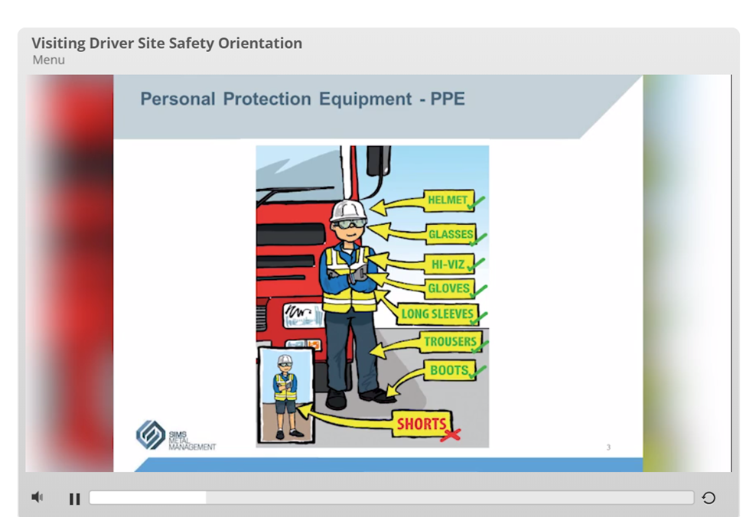

**SHIPPING**

It is very important that all drivers conduct themselves in a positive, polite, and business-like manner.

**Outbound Shipping** Domestic distribution is to steel mills, foundries, smelters and other downstream processing facilities/plants.

* Clean containers without leakage and in good condition are required
  + Pics are taken of the container, load, and seal before leaving a facility
* Loads are palletized, stretch wrapped either on 40x48 GMA pallets or in gaylords or super sacks.
  + Some shipments are large bales
  + SM will load some containers with loose material loaded via conveyors and acculoaders
* Average container weighs 40,393.1 pounds on 33 pallets
  + Some shipments may require an overweight (O/W) permit
* Cartage Companies are generally given one-week notice.
* Booking are usually one to three weeks out from cut-off
  + A booking may contain 1 to 13 Containers
    - The norm is between 1 to 3 Containers per Booking
  + Loading time is generally 1 to 2 hours.
    - Unless an ACCULOADER is used, then it is 15 minutes
    - Not all facilities have an ACCULOADER (See Schedule 2.1b column Q & Video on RFP Portal)
* Containers used for SLS are either 20 ft. (2.0%), 40 ft. HC (83.3%), or 45 ft. HC (14.7%)
* Tri-Axle chassis are needed for some 20 ft. Container Shipments
* Containers used for SM are either 20 ft. (10%), 40 ft. STD & HC (89%), or 45 ft. HC (1%)
  + Tri-Axle chassis are needed for some 20 ft. Container Shipments
* Driver signs for load but Shipments are sealed and shipped ‘Shippers Load and Count’ (SLC)
  + Pics are taken of the MTY Container then of the Fully Loaded Container (as required from our Vendors)
* Annual TEUs with SLS & SM is 50,000 the annual breakdown by facilitiy is in the excel file (Schedule 2.2 Series).
* Not all Export containers are live loads
  + A majority of them may require the drayman to drop the container(s) and pick them up several days later
    - These lanes are identified in the various worksheets (*“Drop Container”)*
      * You may need to Drop several containers at a time
* The end of the month is the busiest

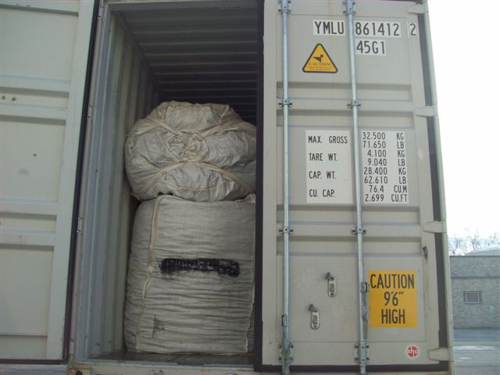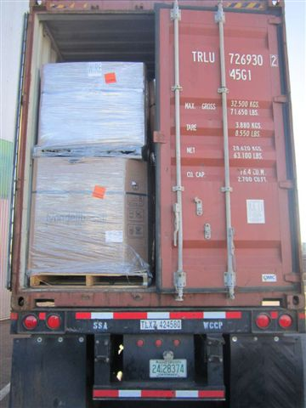

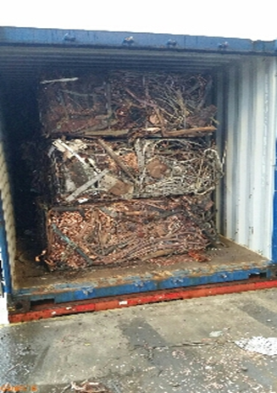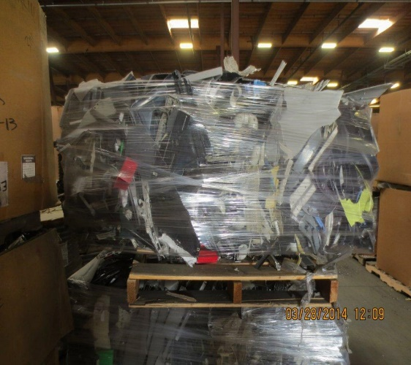

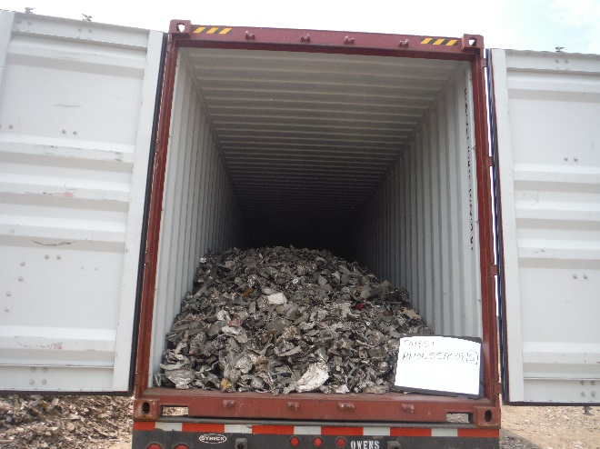

# **PAYMENT**

SM and SLS currently pay their invoices through a third-party audit provider, Ratelinx ([www.ratelinx.com](http://www.ratelinx.com)). RateLinx (or a comparable service provider) will act as a pay agent on behalf of both companies (SM & SLS) and will send funding to the carrier for valid freight charges. While RateLinx will act as pay agent, SM & SLS will be ultimately responsible for payment of legitimate freight charges.

The method for submitting your freight invoices through RateLinx (service provider is subject to change):

*RateLinx Web Portal*

* 1. Using the portal, you do not have to create an invoice; the information entered into the portal will generate an invoice for you. Entry through the portal also assists in you receiving your payment faster because the portal will prompt you if you enter a MMO or Ticket number that does not match our records.
* Payment is made within terms (preferred with a discount) or Net 30 days from date of received invoice
* ALL invoices must be submitted in a timely and accurate manner
  + All Charges need to be submitted with the original invoice
    - This is extremely important so that we may correctly close the business cycle with our customers
* For Deliveries and Pick-ups, we require Proof of Delivery (POD) or Interchange Receipt (TIR) attached (electronically) to the freight invoice.
  + Reference the Bill of Lading number along with the Material Management Order number (MMO) or Ticket # and the Container #(s)
  + Each charge with a shipment needs to be a separate line item
    - Fuel Surcharge NEEDS to be separated from the Line-Haul Rate
    - All the charges for each shipment must be on the invoice
      * Multiple invoices cause delay in payments and are unacceptable

**OTHER REQUIREMENTS**

* Sign an MSA Agreement (the Transportation Vendor Services Agreement) covering among other things the following:
  + Expectations
  + Rates & Accessorial Fees (Submitted from the RFP)
  + Responsibility
  + Liability
  + Insurance
    - Requires ‘Additional Insured’ endorsements along with Waivers of Subrogation
    - Cardo needs to include loss & theft of material
  + Safety
  + Invoicing & Payment
  + Handling of Material
  + Confidentiality
  + Brokers/Carriers Responsibility
* A Credit/Reference Check maybe requested (Dun & Bradstreet)
  + Need to be in business for 5+ years
  + Payments to vendors/carrier need to be listed as current
  + Financial Stability needs to be listed as *MODERATE* or better

**PERFORMANCE REPORTS**

SM & SLS will require the selected carrier(s) to provide a performance report on a weekly basis, on the previous week’s shipments. This report would include:

Previous week's shipments including ALL exceptions to standards along with an explanation of the exception(s).

* Number of containers tendered
* Number of containers accepted
  + Reason why loads were turned down
* the weight of each shipment
* Current DOT Safety Rating
* Current CSA Scores

Quarterly Business Review (QBR) with SM/SLS representatives either in person or via conference call to be arranged by SIMS. Topics to include:

* Quarterly & YTD (Year to Date) activity provided in advance of meeting
* Current DOT Safety Rating and SMS Scores will be reviewed Quarterly
* CTM (Collaborative Transportation Management) - Open discussion to keep cost down and improve service levels.

This report should include **ALL** the exception(s) and why there were exceptions to the standard. SM and/or SLS will also require immediate notification of any discrepancy discovered after shipment pick-up. The reports should be available to be sent electronically at the beginning of the following month on a specified day to an email address that will be determined at a later date. In addition, the management staff at SM and/or SLS would also like to have quarterly meetings to review these reports and discuss ways in which they may help you achieve a high level of service while keeping the costs down.

**EXHIBIT A**

**A.2 SUBMITTING YOUR BID**

Contained in this RFP package is a spreadsheet (**Schedule 2.1a**) entitled “***Carrier Profile and Information***.” This exhibit asks for general information about your company, as well as daily equipment availability, and **MUST** be completed and included with your bid package.

***Drayage***

**Schedule 2.2** Series - Specific Line-Haul Rates per Container to the Railhead/Port (Door to Ramp/Port)

*This exhibit is for specific container moves*

* **CY City** (column C) – Indicates the City in which the container will be picked up
* **CY St**. (column D) – Indicates the State in which the container will be picked up
* **CY Zip Code** (column E) – Indicates the Zip code in which the container will be picked up
* **Origin City** (column F) – Indicates the City in which the container will be loaded/unloaded
* **Origin St** (column G) – Indicates the State in which the container will be loaded/unloaded
* **Orig. Zip Code** (column H) – Indicates the Zip code in which the container will be loaded/unloaded
* **Shipping/Receiving Hours** (column I) – Indicates the hours during which the load maybe available for pick-up/drop-off
* **Appoint. Needed** (column J) – Indicates whether an appointment is needed to pick up/drop off a load
* **Willing to Drop a Trailer** (column K) – Indicates whether a Container may be dropped for loading
* **Port/Ramp City** (column M) – Indicates the City in which the container will be delivered
* **Port/Ramp St** (column N) – Indicates the State in which the container will be delivered
* **Port/Ramp Zip Code** (column O) – Indicates the Zip code in which the container will be delivered
* **Wkly Equip Avail**. (column Q) – Enter here the quantity of containers available on this specific lane
* **Miles** (column R) – Indicates the distance in miles from CY to Origin to Port/Ramp
* **Annual Loads** (column S) – Indicates the number of monthly loads available on this specific lane as determined from data Jul 2019 to Dec 2019.
* **Carrier Name** (column T) – Enter here your Carrier name
* **D to R 20 ft., 40 STD or HC ft., & 45 ft. STD or HC Lengths** (columns V;X;Z) – Enter here the cost per container move by container length (a move is considered picking up an empty trailer/container, taking it to a generator facility to be loaded, and delivering it to the specified origin rail ramp)
* **Instruction/Remarks** (column AA) – Additional Information concerning the lane

**Please note equipment requirements. Provide rates only on those moves where you have the specified type of equipment.** For the purpose of this bid, rates on moves within the U.S. and between Canada and the U.S for U.S. destinations must be stated in U.S. dollars

Mileage will be determined by the **PC Miler program** version 37. In addition, the miles (column AE) in the Schedules 2.2 series were determined with this program. If you are awarded the business on these lanes, it is expected that this is the mileage base that will be used for billing.

All proposed pricing **must be without** fuel surcharge. We are enclosing a proposed fuel surcharge schedule (**Schedule 2.3**). We prefer that all carriers be party to this schedule.

Again, you must complete the “*Carrier Profile and Information*” - **Schedule 2.1A**. This Schedule **must accompany** all bid proposals. Provide your bid pricing with the use of the attached excel spreadsheet, make a copy for yourself, and email it to the address listed below, in the *‘Subject Line’* please put **DRAYAGE PROPOSAL February 2025**.

The term of your proposal relating to rates should be effective for a minimum of one year possibly multiple years. Prior to implementation, potential participants will be asked to meet with us at the respective facility (s). The meeting date and place will be determined after the bid responses have been processed. Each carrier will be given ample opportunity to discuss operational matters.

Any additional rules not addressed in this **Exhibit A** should be referred to in your rules tariff and a copy of such tariff must be provided with your bid.

**Pricing Guidelines:**

* Loading and Unloading free time (per stop) – 3 hours
* Container Order Not Used (TONU) - $100 *if already dispatch and on the way*
* Driver Detention - $50/hr. *– increments of quarter hour*
* Pre-Pull – $100
* Daily Chassis Rental - $20/day for the SSL that charge
  + A number of Steamship Lines (EVERGREEN*{All Origins}*, HYUNDAI *{West Coast}*, MAERSK *{LA/San Pedro}*, MSC *{All Origins}*, ONE (LA/San Pedro),& YANG MING *{West Coast}*) have chassis rental as part of the Sims’ Rate Structure, thus these would be no charge in those instances.
* Additional Fees/Tolls/Passes - Pass through with a receipt
* Scale Ticket Fee – n/c if our facility has a certified scale otherwise pass through with a receipt
* Drop Container - n/c
* California Carb Compliance(<https://ww2.arb.ca.gov/sites/default/files/2023-12/TRUCRS_Online_Reporting_Guide.pdf>)

As an exporter Sims is able to participate in any **Street Turns** that you may have. Because this eliminates the steps of terminating the empty and picking up another at the port/railhead, we would like a percentage discount (%) off of the line-haul rate ($). You may enter a discount percentage when a Street Turn Container is used in the excel spreadsheet on the Carrier Profile Tab (Schedule 2.1a) column BX4 & BY4.

The Bidder’s proposal and service has to fully comply with the requested specifications as well as all the terms and conditions as mentioned in this RFP. The Bidder should meet or exceed the specifications as set out in this RFP document. Prices offered must be met and must be held until services and goods are delivered and or installed, if applicable. No escalator clauses will be accepted unless mutually agreed upon.

**PREFFERED CARRIER**

Awarded transportation providers may (or in the case of SLS, an R2 Certified Recycler, will) be asked to complete a questionnaire from our Safety Health Environment and Community (SHEC) team to verify regulatory authorizations and compliance.  Sample questions may include:

1. *Does your company have an emergency response plan that addresses potential accidents or other incidents during transport?*
2. *Has the company received any fines, regulatory orders, or experienced any environmental incidents such as spills in the past 3 years?*
3. *Is there a controlled substance abuse program, e.g. DOT program for truck drivers?* 
   1. *When was the last time a driver went for a random drug/alcohol testing?*
4. *If a Freight Broker*
   1. *How are Carriers Selected*
   2. *What is the Mythology to ensure Carrier Compliance to Contract Standards*

A review of the transportation providers will also be conducted with the U.S. DOT on-line database*.*

Please bid only those lanes that you have both interest in and equipment availability for to serve on a regular basis. Occasional equipment availability will not be acceptable. **It is not required that you participate from all locations on all lanes – only those locations and traffic lanes where you can provide equipment and service on a regular basis.**

If you are interested in any of this business, please respond with questions directly to:

**Stephen McCleary, CSCP**

**Director of Transportation – North America**

**Sims Metal**

**200 West Madison, Suite 3950**

**Chicago, IL 60606**

**Telephone +1 (630) 473-6041**

**Mobile +1 (630) 779-3121**

[stephen.mccleary@simsmm.com](mailto:stephen.mccleary@simsmm.com)

or

**Cristal Cole**

**Transportation Compliance Manager - NAM**

**Sims Metal**

**15000 Southlawn Lane**

**Rockville, MD 20850**

**Telephone - +1 (410) 637 6807**

**Mobile +1 (202) 381 8866**

[cristal.cole@simsmm.com](mailto:cristal.cole@simsmm.com)

Should you have any questions, please call Steve McCleary or Cristal Cole at the above numbers. We ask that you not contact the facilities directly at this time. All completed bids need to be sent to:

[SIMS.TRANSPORTATION.BIDS@simsmm.com](mailto:SIMS.TRANSPORTATION.BIDS@simsmm.com)

Do **NOT** send to Steve or Cristal directly.

Please review the information carefully and complete your response (including with respect to the Exhibits and completion of the Schedules) with your best proposal. We require your bid package, in hand, by:

**7 February 2025**

Thank you for your consideration and effort. We look forward to hearing from you.

Sincerely,

**Stephen R McCleary**

**Cristal Cole**

**SCHEDULES TO EXHIBIT A**

Attached are the following exhibits that are formatted in Excel 2007 for Windows. The schedules detail the annual outbound and inbound truckload activity.

* Schedule 1 – Affiliates
* Schedule 2.1a – Carrier Profile and Information
* Schedule 2.1b – Facilities Addresses
* Schedules 2.2a – New England Lanes: ( Rhode Island, Connecticut)
* Schedule 2.2b - Southwest Region Lanes: (Texas, Oklahoma)
* Schedule 2.2c - Midwest Region Lanes: ( Illinois, Ohio, Indiana)
* Schedule 2.2d - West Region Lanes (California, Nevada)
* Schedule 2.2e - Southeast Region Lanes: (Virginia)
* Schedule 2.2f - Metro (East Coast) Region Lanes: (New Jersey, Pennsylvania)
* Schedule 2.2g - Mid-South Lanes (Tennessee)
* Schedule 2.2h - Mid-Atlantic Baltimore, MD
* Schedule 2.2i - Arizona Lane
* Schedule 2.2j - Alumisource (PA, OH)
* Schedule 2.2k - Atlanta (GA)
* Schedule 2.3 - Uniform Fuel Surcharge Index

**Exhibit B**

**INSURANCE REQUIREMENTS**

Both SM & SLS use a service called MyCOI ([www.mycoi.com](http://www.mycoi.com) ) to maintain and track all the insurance certificates with our vendors. If selected as one of our transportation providers you will be required to register with them and have a current copy of your COI on file. The basic requirements are:

* Workers’ Compensation Insurance which shall fully comply with the statutory requirements of all applicable state and federal laws; and
* Employers’ Liability Insurance which limit shall be $1,000,000 per accident for Bodily Injury and $1,000,000 per employee/aggregate for disease; and
* Commercial General Liability Insurance with a minimum combined single limit of liability of $1,000,000 per occurrence and $2,000,000 aggregate for bodily injury, death, property damage and personal injury. This policy shall include products/completed operations coverage and shall also include contractual liability coverage; and
* Business Automobile Liability Insurance covering all owned, hired and non-owned vehicles and equipment used by Carrier with a minimum combined single limit of liability of $1,000,000 for injury and/or death and/or property damage; and
* Cargo to include loss and theft of Material
* Carrier shall be responsible for loss to Sims property and its customer property, directly or indirectly, and shall maintain fidelity bond or crime coverage for the dishonest acts of its employees
* We will need additional insured endorsements, primary non-contributory, and waiver of subrogation for General Liability & Automobile Liability

**RFP TERMS AND CONDITIONS**

1. Bidders shall bear all costs associated with the preparation and submission of bids. SM/SLS will not under any circumstances be responsible or liable for such costs, regardless of the conduct or outcome of the RFP process.
2. No bidder shall have any claim for any compensation of any kind whatsoever as a result of participating in this RFP. By submitting a bid, each bidder shall be deemed to have agreed that it has no such claim. Without restricting the generality of the foregoing, each bidder, by submitting a bid, agrees that in the event any or all bids are rejected or disqualified for any reason, or the project or this RFP process is modified, suspended or cancelled for any reason (including modification of the scope of the project or modification of this RFP):
   * 1. Bidders waive any and all claims whatsoever, including claims for loss of profits or loss of opportunity;
     2. Neither SM nor SLS, nor any of their affiliates, nor any of their employees, advisors or representatives (each a SM Party) will be liable, under any circumstances, for any claim or to reimburse or compensate any bidder in any manner whatsoever including but not limited to costs of preparation of a bid, loss of anticipated profits, loss of opportunity or for any other matters; and
     3. Neither SM nor SLS is bound to explain its decision to no unsuccessful Bidders.
3. The Bidder shall not subcontract or sublet part or the entire requirement of this RFP without written approval from SM or SLS.
4. SM or SLS are entitled to incorporate part or the entire RFP response in an agreement with the bidder as appropriate.
   * 1. This RFP does not constitute an offer to enter into any contract with any party, including any bidder, nor does it represent a contract or agreement between any party, including any bidder, and SM or SLS.
     2. This RFP does not constitute an offer to buy, lease, or hire goods, property, or services.
     3. Neither SM nor SLS is bound to award a contract to any party, including any bidder.
     4. Neither SM nor SLS is bound to evaluate or accept any bid, and each reserves the right, in its sole discretion, to:
        1. not consider any or all bids;
        2. clarify, modify or amend the terms or contents of this RFP at any time;
        3. waive, or request that any bidder clarify or rectify, any obscurity, deficiency, defect, omission, non-compliance or other failure to comply with the terms and conditions of this RFP found in any bid that, in the sole discretion of SM or SLS, is deemed not to be material, and proceed to evaluate that bid, as submitted or as so clarified or rectified; or
        4. determine the following, without regard to any industry custom or practice in the exercise of its discretion:
           1. materiality of any obscurity, deficiency, defect, omission, non-compliance or other failure to comply with the terms and conditions of the RFP;
           2. whether or not to:

disqualify any bid;

waive any obscurity, deficiency, defect, omission, non-compliance or other failure to comply; and/or

require or invite clarification and/or rectification; and/or

* + - * 1. the adequacy and acceptability of any clarification or rectification submitted by a bidder;
      1. amend, postpone or cancel any part or phase of this RFP process at any time and for any reasons, including extending the time and date of the closing of the RFP;
      2. cancel this RFP process in its entirety at any time and for any reasons, and in its sole discretion and if and as it sees fit re-issue an RFP or request for qualifications, quotations, proposals, bids, tenders or expressions of interest in relation to the same or a similar project at any time and from time to time;
      3. accept any bid in whole or in part, and with or without negotiations, that, in SLS’s or SM’s sole discretion, offers the best overall value to SLS, and in particular reserves the right in its sole discretion to accept a bid other than:

the bid with the lowest financial cost to SM or SLS; or

the bid with the highest rating at the conclusion of evaluation by SM or SLS;

* + - 1. conduct post-closing negotiations with one or more bidders as it deems appropriate or necessary in its sole discretion, without under any circumstances disclosing information contained in any bid to any other bidder;
      2. amend, postpone or cancel the project that is the subject matter of this RFP, including alteration of any dates or scheduling in relation to the project that is the subject matter of this RFP; and/or
      3. Reject any or all bids.

1. SLS & SM are under no obligation to:
   1. interpret or respond to questions from interested parties or bidders;
   2. return any bids;
   3. accept any bids;
   4. accept the bid with the lowest financial cost to SM or SLS;
   5. accept the bid with the highest rating at the conclusion of evaluation by SM or SLS; or
   6. enter into a contract with any party, including any bidder, in respect of the project that is the subject matter of this RFP.
2. SLS & SM reserve the right to modify the proposed schedule of events as necessary.
3. Attempts to contact any other person or departments directly regarding this RFP may result in disqualification.