**­­**

**REQUEST FOR PROPOSAL**

**TRUCKLOAD SHIPMENTS (Van & Flatbed)**

**This RFP package is confidential; please only share this information with members of your organization and affiliates**.

**MAR 2024**

**On behalf of Sims Group USA Holdings Corporation and USA Affiliates**

By: Stephen McCleary, CSCP

Director of Transportation – North America

Sims Metal

200 West Madison Street, Suite 3950

Chicago, IL 60606

Telephone +1 (630) 473-6041

Mobile      +1 (630) 779-3121

[stephen.mccleary@simsmm.com](mailto:stephen.mccleary@simsmm.com)

[www.simsmm.com](http://www.simsmm.com)

and

Cristal Cole

Transportation Compliance Manager - NAM

Sims Metal

15000 Southlawn Lane

Rockville, MD 20850

Telephone - +1 (410) 637 6807

Mobile +1 (202) 381 8866

[cristal.cole@simsmm.com](mailto:cristal.cole@simsmm.com)

[www.simsmm.com](http://www.simsmm.com)

**RFP NO: NAM 001**

**Overview**

By means of this request for proposals (RFP), Sims Group USA Holdings Corporation, which along with its United States affiliates does business as Sims Metal (SM, global website: [www.s. mm.com](http://www.simsmm.com)), is seeking bids from properly qualified Transportation Service Providers (TSPs) as described below. The bid may also or just include Services for Sims Recycling Solutions, Inc. (SLS, USA website: [https://www.simslifecycle.com](.%20w.simslifecycle.com)), also a United States affiliate of SM.

SLS works closely with recognized industry associations to ensure that its business operations adhere to recognized industry standards; SLS has obtained and maintains the following certifications: R2v3; ISO 14001:2015; ISO 451001; 2018; ISO 9001:2015; ISO 27001; 2013; ITAR Registered.

The intent of this RFP is to offer carriers/brokers the opportunity to bid on various lanes by SM & SLS. All carriers/brokers are encouraged to consider during your proposal development that SM & SLS offer year-round (no peaks/valleys) moves to its preferred Transportation Service Providers. The Transportation Service Providers will honor their proposed rates in this RFP for a minimum of 1 year and will not impose any increases during that term.

Pricing is to be based online-haul rates ONLY, without a fuel surcharge. Our Fuel Surcharge Index is attached. Lanes will be awarded on a primary and secondary transportation provider level. The most competitive Transportation Provider with the best service offering is expected to carry the majority of the lane.

**I. Introduction**

SM/SLS are pleased to invite you to submit a formal proposal for Truckload Shipments (Van & Flatbed), which must conform to the requirements set out in this RFP.

SM/SLS intend to select the Transportation Service Providers and award the contract to the winning bids resulting from this RFP in May 2024. Your quotation and proposal therefore should remain valid through July 2024 and pricing held valid through June 2025.

**II. General RFP & Project Objectives**

SM/SLS are developing a comprehensive transportation program. As such, we would like to offer your company the opportunity to participate in this program. Thank you for your consideration and cooperation.

The selected Transportation Service Providers awarded the traffic lanes are expected to:

* Follow their rates and fees in this bid as shipments are tendered.

Transportation Service Provider will be required to promptly report any employee injury related to the Services, no matter how small, to SM/SLS.

**III. Critical Components of the RFP package that will be evaluated to identify the successful TSP bid.**

* Ability to adhere to our RFP format and fill out the information in its entirety.
* TSP flexible working hours if needed.
* RFP Elements and requirements for submitting your bid are described in the attached **Exhibit A (A.1 & A.2 respectively).**
* Itemized Cost of components as per bid sheet attached as **Schedules 2.1a & 2.2 (B, & C Series).**
* Bidder cannot subcontract any aspect of this bid (or the Services if selected) except with the express written consent of SM/SLS; and
* TPSs must execute SM’s Transportation Vendor Services Agreement (available once the TSP is selected & awarded lanes) and comply with the SM/SLS insurance requirements, as listed in **Exhibit B.**
* TSPs must be able to service those SM/SLS Facilities listed in **Schedule 1 (Affiliates)**.

**IV. Bidder’s basic submittal requirements:**

1. Complete proposal
2. Quotation to be itemized and provided in US$
3. Quotation Validity through performance of Services
4. Specified Payment Terms
5. Any exceptions to items requested must be clearly identified.
6. Bid Sheet must be submitted on time and complete.
7. Agreement to execute the SM/SLS Transportation Vendor Services Agreement and acknowledge and comply with the SM/SLS Insurance requirements, if selected
8. Pricing for Services (all costs)
9. Any proposed exceptions to the SM/SLS Transportation Vendor Services Agreement

**V. All communications regarding this RFP**

For the purpose of this RFP and any resulting communication, please ensure that all queries, comments, suggestions, requests, etc., are communicated by email only to Steve McCleary ([stephen.mccleary@simsmm.com](mailto:stephen.mccleary@simsmm.com)).

**Important;** Please review the entire RFP package first and then consolidate all of your questions and requests in one email. This will eliminate multiple communications and provide a more efficient method in addressing your open items.

This procedure will assist in the streamlining of data and the dissemination of information to all concerned. Where necessary, all questions will be directed internally within SM/SLS and communicated via Steve McCleary to all participating parties accordingly. Failure to adhere to this approach may result in disqualification of proposal.

Please submit your best proposal for the items listed on Exhibits and within the terms and conditions described below. You are required to submit your proposal on our standard forms with separate Exhibits for any additional information you wish to submit.

Due Date:

The due date for submission of proposal is **Mar 29, 2024, by noon.** Proposal must be e-mailed to: [SIMS.TRANSPORTATION.BIDS@simsmm.com](mailto:SIMS.TRANSPORTATION.BIDS@simsmm.com). Formal requests for extension may be made for consideration.

**TERM OF PROJECT:** If awarded this project, all quoted prices and conditions quoted herein shall be in full force and in effect from date of signing to termination of Agreement for Services.

**SCOPE OF PROJECT:** The expected scope of work and components are listed in the excel spreadsheet schedules 2.1 thru 2.3 and within this document.

**RFP DOCUMENTATION INSTRUCTIONS AND NOTES**

* RFP – Electronically fill out company information, name, and phone # with Schedules 2.1 & 2.2 filled out in their entirety.
* RFP Bid Pricing Worksheet – You must indicate your unit cost for each section listed. Do not include any Federal, State, Local or Use Taxes in your pricing.
* TSPs will be responsible for complying with the SM/SLS SHEC (safety, health, environmental & community) requirements and to comply with local, state, and federal laws and governmental requirements pertaining to SHEC.
* State your warranty/guarantee for all services provided.

**Summary of Important Due Dates:**

* Bid Submittal Date: **March 29, 2024, 12:00 pm CST.**
* Contract Awarded: **June 2024 (subject to change)**

***[Remainder of page intentionally left blank.***

**EXHIBIT A**

**A.1 RFP ELEMENTS**

**PRODUCTS**

SM receives recyclable metal materials and ships recyclable metal commodities. SLS receives and ships electronic materials and products. In addition to these products, both businesses also ship their wastes.

A sampling of materials received and/or shipped by SM and/or SLS includes (but the below list also includes items not received or shipped by either business, e.g., “games group,” or “gums”):



**REQUIREMENTS:**

**SAFETY**

The culture of SM/SLS is built around its core values of Safety, Integrity, Respect, Transparency, Excellence, and Social Responsibility. These core values determine who SM/SLS are and are the foundation of everything SM & SLS do; they set the standard for the way SM & SLS interact with its employees, customers, communities, and all stakeholders, including its vendors.

The first of those core values is Safety. SM, & SLS strive for a “ZERO-harm workplace.”

* SM/SLS require drop trailers in docks to use wheel chocks & stands.
* A number of SM/SLS facilities have ‘Dock Locks’ and/or they may also use ‘Air Brake Locks’
* Drivers may be asked to lock their keys in a secure lock box until the trailer is completely loaded or unloaded.
* Please ensure all drivers review the Safety Video attached to the Web Page in the Bid Portal (*SAFETY VIDEO Dec20*)

**SHIPPING / RECEIVING**

It is especially important that all drivers conduct themselves in a positive, polite, and business manner. This might be the only interface that our customers/vendors have with SM/SLS, and your driver represents our business.

**APPOINTMENTS**

It is EXTREMELY IMPORTANT that ALL appointments are kept & met *(some SM/SLS Customers/Vendors keep a scorecard with pick-ups & deliveries and may assess penalties and fines against SM/SLS, which will be passed along to your company)*

* + *Once a Pick-up/Shipment is confirmed, if it is dropped by the Carrier within 12 hours or the night before, the TONU charge may be applied to the carrier by SM/SLS.*

**SM Inbound & Outbound Shipping**

* Appointments are not needed at most SM locations (see Schedule 2.1b in Excel file)
  + Those locations operate on a First Come First Served basis.
* Clean trailers without leakage are required.
  + For the purpose of this bid:
    - 48’ or 53’ Dry Van Trailers ONLY
    - Flat beds
    - Other types of equipment are utilized (please complete section: ‘Carrier Profile Schedule 2.1a {columns CD thru CN})
* Average weighs in pounds (lbs.):



* Carriers are generally given 24 to 48 hours’ notice but can have same day pick-up.
* Driver signs for the load but shipments are generally shipped ‘Shipper Load and Count’ (SLC) and sealed.
  + Copies of the Driver’s License will be taken and placed on file with each outbound Load.
* For ALL outbound loads, a POD is required and will need to be uploaded to the Invoice in Ratelinx
  + In addition, it is required to be emailed to the individual at Sims who tendered the shipment within 3 days of the delivery.
* The preference is for the selected carrier/broker able to provide access to the Web Portal with real time tracking of shipments from origin to destination with a bread crumb trail (Schedule 2.1a Column AO)
* Currently, shipments are usually tendered through our TMS system (Ratelinx {www.ratelinx.com})
  + Rates from this bid will apply with this on-line tendering.
* Unloading and loading time is usually within 2 hours.
* For safety, drivers will be asked to un-hook from the trailer or have their keys locked in a secure lock box until the trailer is completely loaded or unloaded.
* Please refer to the Excel file *(SLS_SM_TRUCKLOAD SCHEDULES.xls* worksheet Schedule 2.1B) for Sims Metal’s yard locations and hours of operation.
* Car Body Hauling **(see pictures below)**
  + Spread Axle Trailers
  + Requires 3 chains per stack of cars.
    - Stacks must be tarped or netted (per federal and/or State requirements)
  + “Wet” Cars – Rims/tires still on the vehicle
    - Vehicle NOT flattened.
    - Fluids still in the vehicle
  + Crushed Cars
    - Rims/tires may or may not be on the vehicle.
    - Fluids drained.
    - Vehicles Flattened

***EXAMPLES of CARS STACKED on a FLATBED (DEPICTION IS NOT REPRESENTATIVE OF COMPLIANCE REQUIREMENTS)***

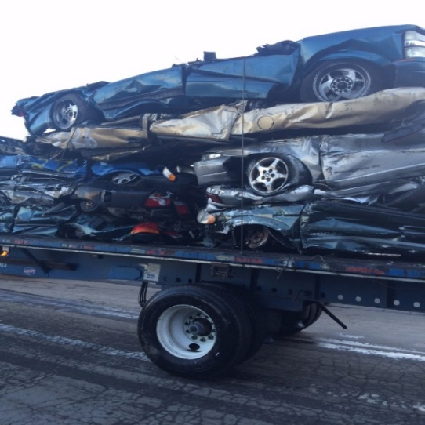



***PICS OF LOADS (VAN TRAILERS)***

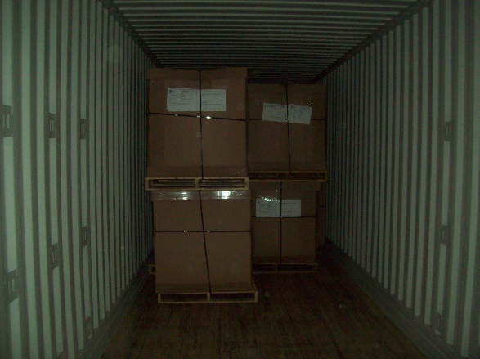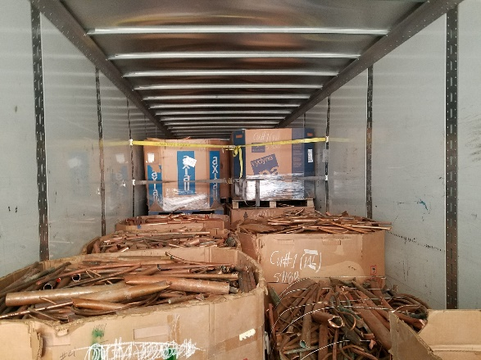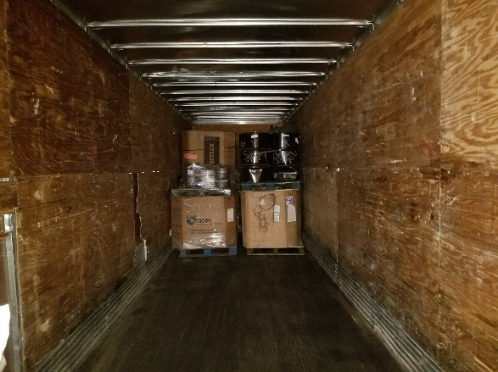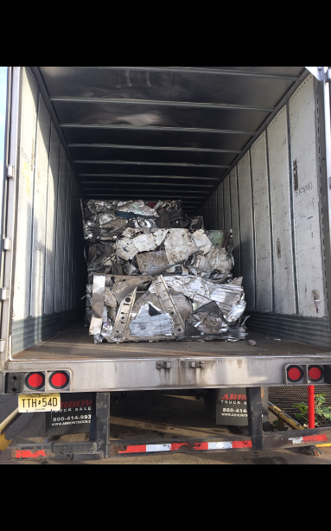

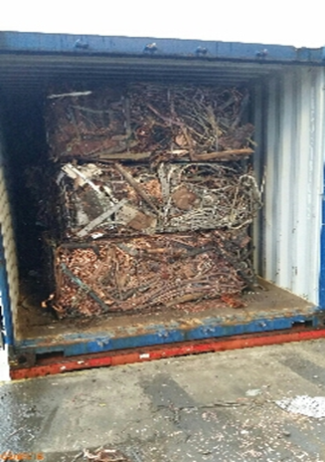

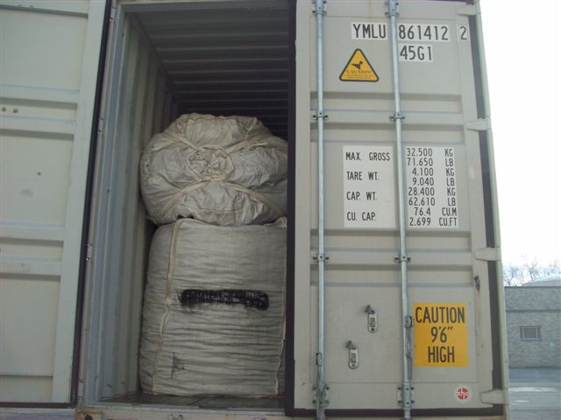

# **.**

***PICS OF TIN BALE LOADS w/NETTING***

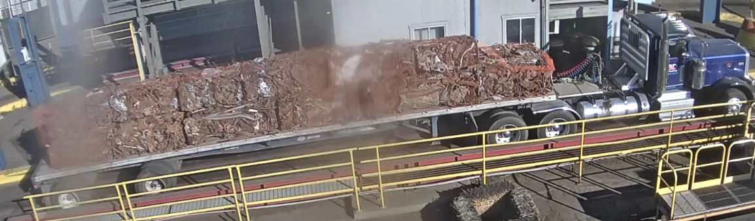

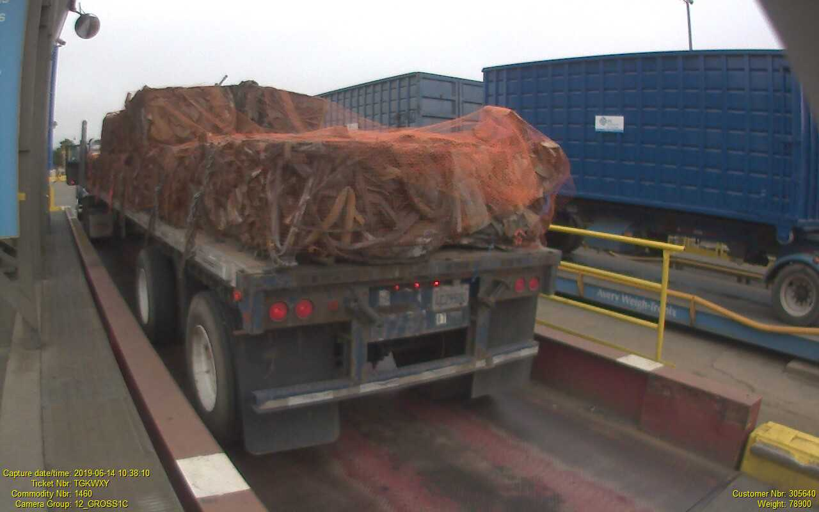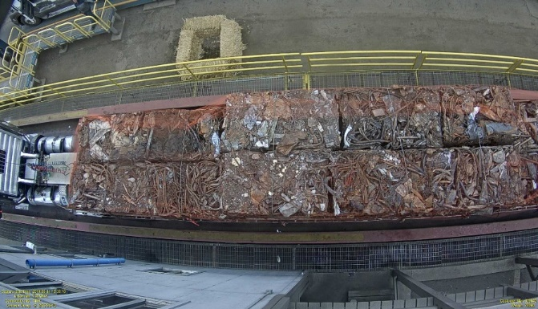

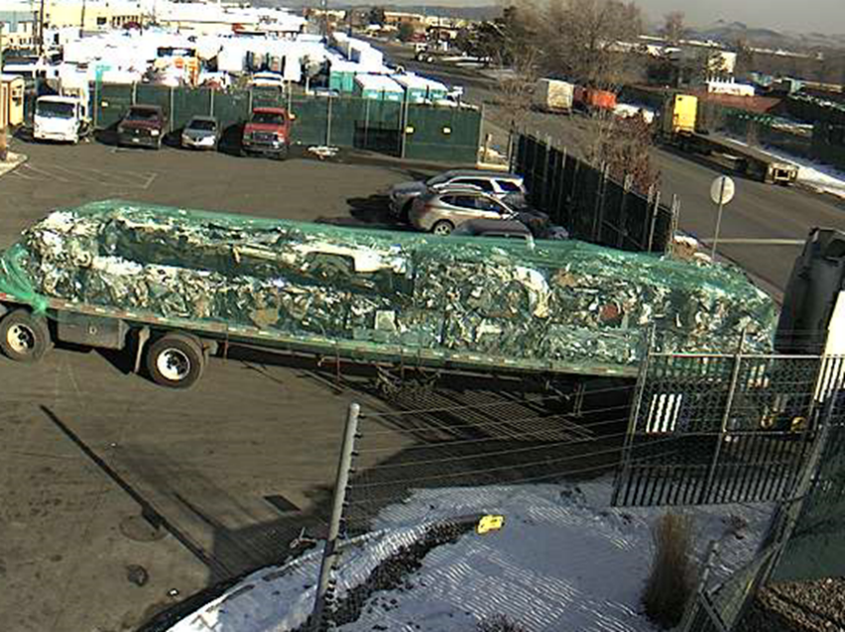

# **PAYMENT**

SM/SLS currently pay their invoices through a third-party audit provider, Ratelinx ([www.ratelinx.com](http://www.ratelinx.com)). RateLinx (or a comparable service provider) will act as a pay agent on behalf of both companies (SM & SLS) and will send funding to the carrier for valid freight charges. While RateLinx currently will act as pay agent, SM & SLS will be ultimately responsible for payment of legitimate freight charges.

The method for submitting your freight invoices through RateLinx (service provider and method are subject to change):

*RateLinx Web Portal*

* 1. Using the portal, you do not have to create an invoice; the information entered into the portal will generate an invoice for you. Entry through the portal also assists in you receiving your payment faster because the portal will prompt you if you enter a MMO or Ticket number that does not match our records.
* Payment is made within terms Net 30 days with a 2% discount for Net 10 from date of received invoice.
* ALL invoices must be submitted in a timely and accurate manner.
* All Charges need to be submitted with the original invoice.
  + This is extremely important so that we may correctly close the business cycle with our customers.
* For Deliveries and Pick-ups, we require Proof of Delivery (POD), or Interchange Receipt (TIR) attached (electronically) to the freight invoice.
  + Reference the Bill of Lading number along with the Material Management Order number (MMO) or Ticket # and the Container #(s)
  + Each charge with a shipment needs to be a separate line item.
  + Fuel Surcharge NEEDS to be separated from the Line-Haul Rate
  + All the charges for each shipment must be on the invoice.
  + Multiple invoices cause delay in payments and are unacceptable.

**OTHER REQUIREMENTS**

* Sign an MSA Agreement (the Transportation Vendor Services Agreement) covering among other things the following:
  + Expectations/ Service Requirements/ Scope of Work
  + Rates & Accessorial Fees (Submitted from the RFP)
  + Responsibility
  + Liability & Risk Allocation; Indemnification
  + Insurance
  + Requiring Endorsements for Additional Insured along with Waivers of Subrogation
  + Safety & Compliance Requirements
  + Invoicing & Payment
  + Handling of Material
  + Confidentiality
  + Brokers/Carriers Responsibility

**PERFORMANCE REPORTS**

SM & SLS will require the selected carrier(s) to provide a performance report on a weekly basis, on the previous week’s shipments. This report would include:

Previous week's shipments including ALL exceptions to standards along with an explanation of the exception(s).

* Number of inbound & outbound shipments
* Weight of each shipment
* Average transit time
* Percentage (%) of shipments completed on-time.
* Number of loads tendered.
* Percentage (%) of load turned down reason.
* Current DOT Safety Rating
* Current CSA Scores

Quarterly Business Review (QBR) with SM/SLS representatives either in person or via conference call to be arranged by SM/SLS. Topics to include:

* Quarterly & YTD (Year to Date) activity provided in advance of meeting.
* Current DOT Safety Rating and SMS Scores will be reviewed Quarterly.
* CTM (Collaborative Transportation Management) - Open discussion to keep cost down and improve service levels.

This report should include **ALL** the exception(s) and why there were exceptions to the standard.

SM and/or SLS will also require immediate notification of any discrepancy discovered after shipment is.

picked-up. The reports should be available to be sent electronically at the beginning of the following month.

on a specified day to an email address that will be determined at a later date. In addition, the

management staff at SM and/or SLS would also like to have quarterly meetings to review these reports.

and discuss ways in which they may help you achieve a high level of service while keeping the costs.

down.

**PARTICIPATION as a PARTNERSHIP of PREFERRED CARRIERS**

**Auctions**

From Time-to-Time SM, & SLS will go to the spot market with one off lanes. They will use an Auction Tool provided by our 3rd Party Freight Audit and Pay Vendors (Ratelinx – Instruction Included on the Portal). It is expected that as a Preferred Carrier that you would participate in this for each Region (Response needed in Schedule 2.1a – column BZ4)

**RFPs (Request for Pricing) Requests**

Through the year SM/SLS will be updating their static rates and potentially be adding lanes. It is expected that as a Preferred Carrier you would participate in these (Response needed in Schedule 2.1a – column CA4)

**EXHIBIT A**

**A.2 SUBMITTING YOUR BID**

Contained in this RFP package is a spreadsheet (**Schedule 2.1a**) entitled “***Carrier Profile and Information***.” This Schedule requests general information about your company, as well as your daily equipment availability, and **MUST** be completed and included with your bid package.

**SUBMITTING YOUR BID**

***Truckload***

Also enclosed is a workbook with spreadsheets that provide point-to-point freight movements (Schedule 2.2: B series). This Schedule requests per mile and per vehicle pricing for each move. For Schedule 2.2 ‘(a)’ series (Over-the-Road rates): enter your rate in the column entitled ‘*Line-haul Bid Price per Vehicle’* by designated city. Your pricing must be on both a ‘cost per mile’ (column L) and ‘per truckload’ (column M) in the designated cells. In addition, in column G the miles have been calculated for each traffic lane and in column M enter in the minimum charge (in $) if greater than the mileage line-haul rate.

**BREAKDOWN of BID RATE EXHIBITS**

Schedule 2.2 B, series (1&2) - Specific Line-Haul Rates per Truckload

*These Schedules are for specific over-the-road truckload moves.*

* **Origin City** (column A) – the City in which the load will be picked up.
* **Origin St./Prov.** (column B) – the State/Province in which the load will be picked up.
* **Orig. Zip/Postal** (column C) – the Zip/Postal code in which the load will be picked up.
* **Dest. City** (column D) – the city to which the load will be delivered.
* **Dest. St./Prov** (column E) – the State/Province to which the load will be delivered.
* **Dest. Zip/Postal** (column F) – the Zip/Postal code to which the load will be delivered on this specific lane
* **Miles** (column G) – the distance in miles from origin to destination based on PC Miler v37.
* **Monthly Loads** (column H) – the number of monthly loads available on this specific lane as determined from data for Nov 2023 to Jan 2024
* **Carrier Name** (column I) – Enter here your Carrier business’ legal name.
* **Type of Equip** (column J) – Enter here the type of equipment being used to pull the load.
* **Type of Shipment** (column K) – specific requirements with the shipment if any
* **Prop L/H Chg. per Mile** (column L) – Enter here the rate per mile.
* **Prop L/H Chg. per T/L** (column M) – Enter here the cost per truckload for this lane - either the minimum charge or the rate, whichever is greater.
* **Grade Category** (column O) – the type of material being shipped.
* **Currency (US$ or CDN$)** (column P) – Enter here the currency that the rate is based on (US$)
* **Region** (column Q) – the Region that is responsible for the shipment.
* **Remarks** (column S) – Any additional Information may be indicated.

***Intermodal***

For Schedule 2.2 C series (Inter-modal rates): enter your rate in the column entitled ‘D to D T/L Length’ for each size trailer or container that pertains to the designated city. Your pricing must be door-to-door rate per trailer length (columns I through R) in the designated cells. In addition, enter Transit time in days (column T) and the number of trailers available weekly in columns M & S.

Schedule 2.2 C series - Specific Rates per Trailer either TOFC or COFC

*This Schedule is for specific Inter-modal trailer moves (door to door)*

* **Origin City** (column A) – the city in which the load will be picked up.
* **Origin St./Prov** (column B) – the State/Province in which the load will be picked up.
* **Orig. Zip/Postal** (column C) – the Zip/Postal code in which the load will be picked up.
* **Dest. City** (column D) – the city to which the load will be delivered.
* **Dest. St./Prov** (column E) – the State/Province to which the load will be delivered.
* **Dest. Zip/Postal** (column F) – the Zip/Postal code to which the load will be delivered.
* **Monthly Loads** (column G) – the number of monthly loads available on this specific lane as determined from data for Nov 2023 to Jan 2024.
* **Carrier Name** (column H) – Enter here your Carrier business’ legal name.
* **D to D Trailer/Container Size** (columns I-R) – Enter here the rate to move the trailer by size door to door
* **Wkly Equip Avail.** (column M & S) – Enter here the quantity of Trailers/Containers available on this specific lane.
* **D to D Transit Time** (column T) – Enter here in days the time it will take to move the load from the generator’s dock door to the mill’s dock door.
* **Currency US$ or CDN$** (column U) – Enter here the currency that the rate is based on (US$)
* **Type of Shipment** (column V) – any specific requirements with the shipment
* **Grade Category** (column X) – the type of material being shipped.
* **Region** (column Y) – the Region that is responsible for the shipment.
* **Remarks** (column AA) – Any additional Information may be indicated.

**Please note equipment requirements. Provide rates only on those moves where you have the specified type of equipment.** For the purpose of this bid, rates on moves within the U.S. and between Canada and the U.S for U.S. destinations must be stated in U.S. dollars.

Mileage will be determined by the **PC Miler program** version 37. In addition, the miles (column G) in the Schedules 2.2B- (1&2) series were determined with this program. If you are awarded the business on these lanes, it is expected that this is the mileage base that will be used for billing. In addition, as we update our ERP system mileage will be based on HERE program (here.com).

All proposed pricing **must be without** fuel surcharge. We are enclosing a proposed fuel surcharge schedule (**Schedule 2.3**). All carriers should be party to this schedule.

You must complete the “*Carrier Profile and Information*” - **Schedule 2.1A**. This Schedule **must accompany** all bid proposals. Provide your bid pricing with the use of the attached excel spreadsheet, make a copy for yourself, and email it to the address listed below, in the *‘Subject Line’* please put **TRUCKLOAD PROPOSAL MAR 2024**.

The term of your proposal relating to rates should be effective for a minimum of one year and possibly multiple years. Prior to implementation, potential participants will be asked to participate in an online conference to meet with us. The online meeting date and time will be determined after the bid responses have been processed. Each carrier will be given ample opportunity to discuss operational matters.

Any additional rules not addressed in this **Exhibit A** should be referred to in your rules tariff and a copy of such tariff must be provided with your bid.

**SUBMISSION REQUIREMENTS:**

* **Equipment:** Provide rates only on those moves where you have the specific type of equipment.
* **Prices for Canadian movements** are to be exclusive of HST. HST is to be shown as a separate item if applicable.
* **Cross Border:** Carriers must follow PIP (Partners in Protection) and C-TPAT (Customs Trade Partnership Against Terrorism) guidelines. For quicker border crossings, preference is given to FAST TRAC (Free and Secure Trade) participants. Multi-pallet shipments must be kept together to avoid any delays.
* **Mileage** to be determined by PC Miler Program Version 37. Pricing & invoicing must be based on PC Miler. NOTE: Miles in Schedules 2.2B & C in Column G are based on PC Miler.
* **Fuel Surcharge:** Pricing to be **exclusive of fuel surcharge.** SM/SLS fuel surcharge schedules (Schedule 2.3) are included. Carriers must **be party** to these schedules.
* **“*Carrier Profile and Information*”** (Schedule 2.1A): Must be **completed and accompany** all bid proposals.
* **Proposal Term:** Effective for a **minimum of one year.**
* **Proposal Final Submission**: Provide your bid pricing with the use of the excel spreadsheet on-line (https://www.simsmm.com/logistics-freight-rfp/), download it, make a copy for yourself, then email it to the address listed below, in the *‘Subject Line’* please put TRUCKLOAD MAR 2024. *If you prefer, we may provide you with an electronic version of this bid for you to complete and email back to us.*
* **Implementation:** Selected Carriers will be asked to meet with an online conference. The online conference date and time will be determined after the bid responses have been processed. Each Carrier will be given ample opportunity to discuss operational matters.
* **Additional Rules:** Any items not addressed in this Exhibit A should be referred to in your rules tariff and a copy of such tariff must be provided with your bid.
* **Brokers:** Provide carrier selection criteria as well as a schedule on the monitoring of selected carriers.
  + Brokers are NOT allowed to Broker there awarded loads to other brokers. Brokers are only to us the carriers they have under contract as indicated in Schedule 2.1a columns CT thru CV.
* Please bid only those lanes that you have both interest and equipment availability to serve on a regular basis. Occasional equipment availability is **NOT** acceptable.
* **Pricing Guidelines:**
* Pick-up/Delivery Appointments/Notifications, - Waived
* Intermediary Stop-Off Charge - $50 per stop
* Loading and Unloading free time (per stop) – 3 hours
* Trailer Order Not Used (TONU) - $100
* Driver Detention - $50/hr. *– increments of quarter hour*
* Driver Assist - $40
* Minimum Truckload Rate
  + Less than (<) 250 miles - $100
  + Equal to or greater than (>) 250 mile - $250
* O/W Permits – Pass through with a receipt.
* Lift Gate service - $25
* Pallet Jack - $20
* Drop Trailer – No Charge
* Layover - $150
* Full Tarp - $50
* California Carb Compliance(<https://ww2.arb.ca.gov/sites/default/files/2023-12/TRUCRS_Online_Reporting_Guide.pdf>)

The Bidder’s proposal and service must fully comply with the requested specifications as well as all the terms and conditions noted in this RFP. The Bidder should meet or exceed the specifications set out in this RFP document. Prices offered must be met and must be held until services and goods are delivered and or installed, if applicable. **No escalator clauses will be accepted.**

**PREFFERED CARRIER**

Awarded transportation providers may (or in the case of SLS (a R2 Certified Recycler) will) be asked to complete a questionnaire from our Safety Health Environment and Community (SHEC) team to verify regulatory authorizations and compliance. Sample questions may include:

1. *Does your company have an emergency response plan that addresses potential accidents or other incidents during transport?*
2. *Has the company received any fines, regulatory orders, or experienced any environmental incidents such as spills in the past 3 years?*
3. *Is there a controlled substance abuse program, e.g., DOT program for truck drivers?* 
   1. *When was the last time a driver went for a random drug/alcohol testing?*

A review of the transportation providers will also be conducted with the U.S. DOT on-line database along with your current Secretary of State registration*.* A credit check may also be requested.

Please bid only those lanes that you have both interest in and equipment availability for to serve on a regular basis. Occasional equipment availability will not be acceptable. **It is not required that you participate from all locations on all lanes – only those locations and traffic lanes where you can provide equipment and service on a regular basis.**

If you are interested in any of this business, please respond with questions directly to:

**Stephen McCleary, CSCP**

**Director of Transportation – North America**

**Sims Metal**

**200 West Madison, Suite 3950**

**Chicago, IL 60606**

**Telephone +1 (630) 473-6041**

**Mobile +1 (630) 779-3121**

[stephen.mccleary@simsmm.com](mailto:stephen.mccleary@simsmm.com)

or

**Cristal Cole**

**Transportation Compliance Manager - NAM**

**Sims Metal**

**15000 Southlawn Lane**

**Rockville, MD 20850**

**Telephone - +1 (410) 637 6807**

**Mobile +1 (202) 381 8866**

[cristal.cole@simsmm.com](mailto:cristal.cole@simsmm.com)

Should you have any questions, please call Steve McCleary or Cristal Cole at the above numbers. We ask that you not contact the facilities directly at this time. All completed bids need to be sent to with TRUCKLOAD PROPSAL in subject:

[SIMS.TRANSPORTATION.BIDS@simsmm.com](mailto:SIMS.TRANSPORTATION.BIDS@simsmm.com)

Do **NOT** send to Steve or Cristal directly.

Please review the information carefully and complete your response (including with respect to the Exhibits, completion of the Schedules) with your best proposal. We require your bid package, in hand, by:

**29 March 2024**

Thank you for your consideration and effort. We look forward to hearing from you.

Sincerely,

**Stephen R McCleary, CSCP**

Director of Transportation – North America

**Cristal Cole**

Transportation Compliance Manager – North America

**SCHEDULES TO EXHIBIT A**

Attached are the following **confidential** exhibits that are formatted in Excel 2003 for Windows. The exhibits provide basic information about SM/SLS and detail the annual outbound and inbound truckload activity that is the subject of these bids.

* Schedule 1- Affiliates
* Schedule 2.1A – Carrier Profile and Information
* Schedule 2.1B – SM & SLS Locations and Hours
* Schedule 2.2 – Lane Analysis: Inbound & Outbound
  + Schedule 2.2B-1 –SM & SLS Monthly Inbound &Outbound Specific Point-to-Point Loads: Domestic US: (a) Over-the-Road – Van & (b) Inter-modal
  + Schedule 2.2B-2 – SM Monthly Inbound Specific Point-to-Point Loads - Domestic US:

(a) Over-the-Road – Flatbed

* Schedule 2.3 – Uniform Fuel Surcharge Index

**Exhibit B**

**INSURANCE REQUIREMENTS**

Both SM & SLS use a service called MyCOI ([www.mycoi.com](http://www.mycoi.com)) to maintain and track all the insurance certificates with our vendors. If selected as one of our transportation providers, you will be required to register with them and have a current copy of your COI on file. There is a cost for registration.

The minimum insurance coverage requirements are:

* Greater of Bidder’s normal or customary or Statutory Workers’ Compensation Insurance which shall fully comply with the statutory requirements of all applicable state and federal laws.
* Employers Liability at a level greater of Bidder’s normal or customary or $1 million per occurrence for injury or death, including without limitation coverage for occupational disease.
* For employees of Bidder who are Owners of the Bidder, evidence of medical insurance.
* Commercial General Liability (using occurrence form) in an amount Greater of Bidder’s normal or customary or $1 million per occurrence and $2 million aggregate, including Blanket Contractual Liability, Products and Completed Operations Liability, Broad Form Property Damage endorsement, and Personal Injury.
* If using SM/SLS Equipment, Property Damage at the full replacement value of SM/SLS Equipment for physical loss or damage, naming SM/SLS as loss payee.
* Auto Liability in an amount Greater of Bidder’s normal or customary or $1 million per occurrence for Bodily Injury and Property Damage, on all Vehicles Owned, Hired, or Non-Owned, declaring “Any Auto” or the equivalent, using ISO Policy Form CA 00 0103 or later edition.
* Excess/Umbrella Liability (occurrence) in an amount greater of Bidder’s normal or customary or $2 million per occurrence and aggregate, including coverage for all occurrences provided by all underlying coverages specified above (excluding Workers Compensation).
* For transportation of Goods consisting of SM/SLS Equipment or Vanloads or Gaylords or Containers of Goods (e.g. via Drayage, Van, Intermodal or flatbed), Cargo Liability Insurance in an amount greater of Bidder’s normal or customary $100,000 for loads containing Ferrous (FE) Goods and $250,000 for loads containing non-Ferrous (NF) for loss of ,damage to, or theft of Goods carried on any one motor vehicle. If additional amount of Cargo Liability Insurance is required by SM/SLS, the parties will arrange for such applicable additional amounts for the direct incremental cost of such additional coverage to the Bidder (Schedule2.1a Column CB & CC).
* Carrier shall be responsible for loss to Sim’s property and its customer property, directly or indirectly, and shall maintain fidelity bond or crime coverage for the dishonest acts of its employees.
* SM/SLS will need additional insured endorsements for General Liability & Automobile Liability.
* Additional insurance requirements are provided in an Exhibit to the applicable SM/SLS Vendor Services Agreement that each successful transportation services provider will need to sign.

**EXHIBIT C**

**RFP TERMS AND CONDITIONS**

1. Bidders shall bear all costs associated with the preparation and submission of bids. SM/SLS will not under any circumstances be responsible or liable for such costs, regardless of the conduct or outcome of the RFP process.
2. No Bidder shall have any claim for any compensation of any kind whatsoever as a result of participating in this RFP. By submitting a bid, each bidder shall be deemed to have agreed that it has no such claim.

Without restricting the generality of the foregoing, each Bidder, by submitting a bid, agrees that in the event any or all bids are rejected or disqualified for any reason, or the project or this RFP process is modified, suspended or cancelled for any reason (including modification of the scope of the project or modification of this RFP):

* + 1. Bidders waive any and all claims whatsoever, including claims for loss of profits or loss of opportunity.
    2. Neither SM nor SLS, nor any of their affiliates, nor any of their employees, advisors or representatives (each a SM Party) will be liable, under any circumstances, for any claim or to reimburse or compensate any bidder in any manner whatsoever including but not limited to costs of preparation of a bid, loss of anticipated profits, loss of opportunity or for any other matters; and
    3. Neither SM nor SLS is bound to explain its decision to unsuccessful Bidders.

1. No Bidder shall subcontract part or the entire submission or implementation of any requirements of this RFP without written approval from SM or SLS, as applicable.
2. SM and SLS are entitled to incorporate part or the entire RFP response in an agreement with the successful Bidder as appropriate.
   * 1. This RFP does not constitute an offer to enter into any contract with any party, including any Bidder, nor does it represent a contract or agreement between any party, including any Bidder, and SM or SLS.
     2. This RFP does not constitute an offer to buy, lease, or hire goods, property, or services.
     3. Neither SM nor SLS is bound to award a contract to any party, including any Bidder.
     4. Neither SM nor SLS is bound to evaluate or accept any bid, and each reserves the right, in its sole discretion, to:
        1. not consider any or all bids.
        2. clarify, modify, or amend the terms or contents of this RFP at any time.
        3. waive, or request that any Bidder clarify or rectify, any obscurity, deficiency, defect, omission, non-compliance or other failure to comply with the terms and conditions of this RFP found in any bid that, in the sole discretion of SM or SLS (as applicable), is deemed not to be material, and proceed to evaluate that bid, as submitted or as so clarified or rectified; or
        4. determine the following, without regard to any industry custom or practice in the exercise of its discretion:
           1. materiality of any obscurity, deficiency, defect, omission, non-compliance, or other failure to comply with the terms and conditions of the RFP.
           2. whether or not to:

disqualify any bid.

waive any obscurity, deficiency, defect, omission, non-compliance, or other failure to comply; and/or

require or invite clarification and/or rectification; and/or

* + - * 1. the adequacy and acceptability of any clarification or rectification submitted by a Bidder.
      1. amend, postpone, or cancel any part or phase of this RFP process at any time and for any reasons, including extending the time and date of the closing of the RFP.
      2. cancel this RFP process in its entirety at any time and for any reason, and in its sole discretion and, if and as it sees fit, re-issue an RFP or request for qualifications, quotations, proposals, bids, tenders or expressions of interest in relation to the same or a similar project at any time and from time to time;
      3. accept any bid in whole or in part, and with or without negotiations, that, in SM’s or SLS’s (as applicable) sole discretion, offers the best overall value to SM/SLS, and in particular reserves the right in its sole discretion to accept a bid other than:

the bid with the lowest financial cost to SM or SLS; or

the bid with the highest rating at the conclusion of evaluation by SM or SLS.

* + - 1. conduct post-closing negotiations with one or more bidders as it deems appropriate or necessary in its sole discretion, without under any circumstances disclosing information contained in any bid to any other Bidder.
      2. amend, postpone, or cancel the project that is the subject matter of this RFP, including alteration of any dates or scheduling in relation to the project that is the subject matter of this RFP; and/or
      3. Reject any or all bids.

1. SM or SLS are under no obligation to:
   1. interpret or respond to questions from interested parties or bidders.
   2. return any bids.
   3. accept any bids.
   4. accept the bid with the lowest financial cost to SM or SLS.
   5. accept the bid with the highest rating at the conclusion of evaluation by SM or SLS; or
   6. enter into a contract with any party, including any Bidder, in respect of the project that is the subject matter of this RFP.
2. SM & SLS reserve the right to modify the proposed schedule of events, as necessary.
3. Attempts to contact any other person or departments directly (other than the sender) regarding this RFP may result in disqualification.